PART B
(PART B: TO BE COMPLETED BY STUDENTS)
(Students must submit the soft copy as per following segments within two hours of the practical. The soft copy must be uploaded on the Teams or emailed to the concerned lab in charge faculties at the end of the practical in case the there is no Black board access available)
Roll No. | Name:
Program: | Division:
Semester: | Batch :
Date of Experiment: | Date of Submission:
Grade :

B.1 Software Code written by student:
(Paste your Python code completed during the 2 hours of practical in the lab here)

B.2 Input and Output:
(Paste your program input and output in following format. If there is error then paste the specific error in the output part. In case of error with due permission of the faculty extension can be given to submit the error free code with output in due course of time. Students will be graded accordingly.)

B.3 Conclusion:
(Students must write the conclusion as per the attainment of individual outcome listed above and learning/observation noted in section B.1)

Task 1: Write a Python program to check whether a person is eligible for voting or not (accept age from user)
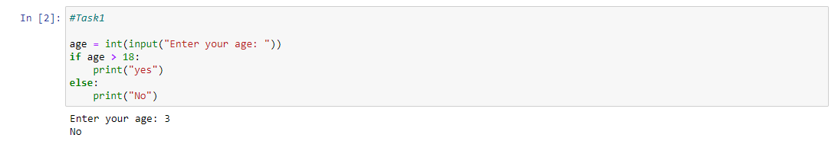
Task 2: Write a program to display “Hello” if a number entered by the user is a multiple of five, otherwise print “Bye”.
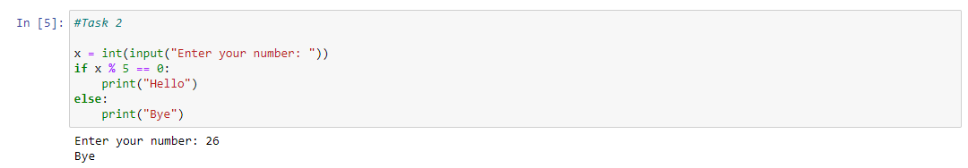
Task 3: Write a Python program to accept percentage from the user and display the grade according to following criteria:
Marks | Grade
>90 | A
>80 and <=90 | B
>=60 and <=80 | C
Below 60 | D

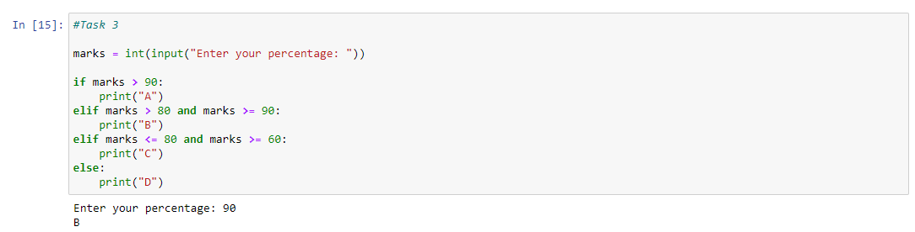
Task 4: Write a program to accept the cost price of a bike and display the road tax to be paid according to following criteria.
Cost Price (in Rs) | Tax
>100000 | 15%
>50000 and <=100000 | 10%
<=50000 | 5%

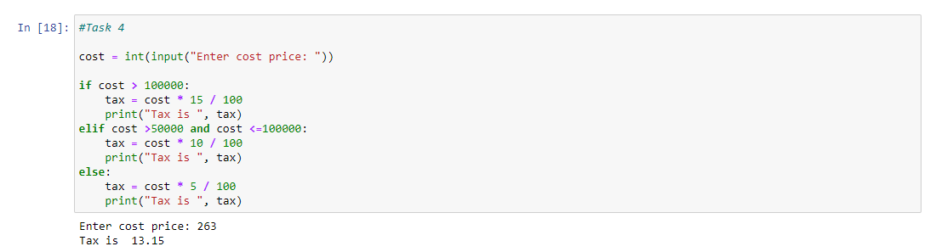
Task 5: Write a Python Program to print first 10 natural numbers.
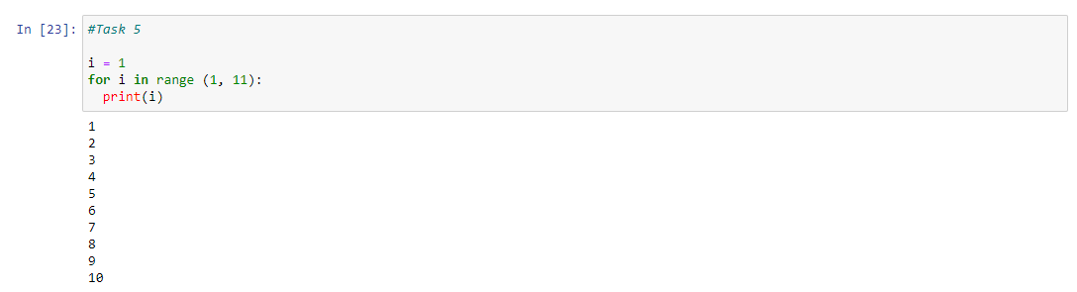

Task 6: Write a Python program to Read a Number n and Print the Sum of odd Natural Numbers between the range of 1 to n both inclusive
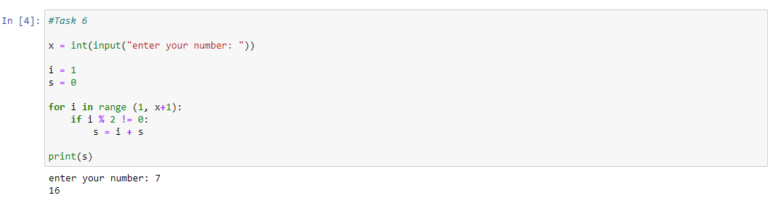
Task 7: Write the output of the following
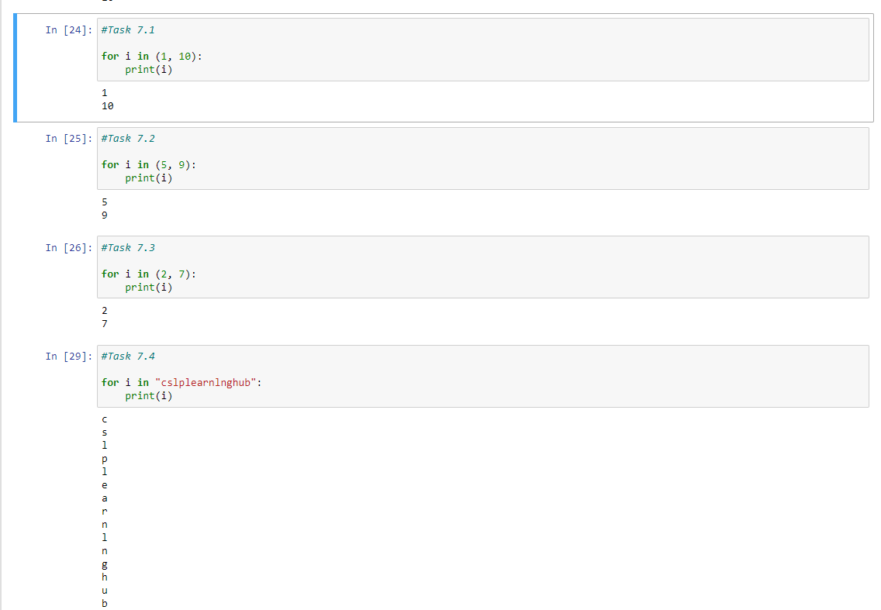
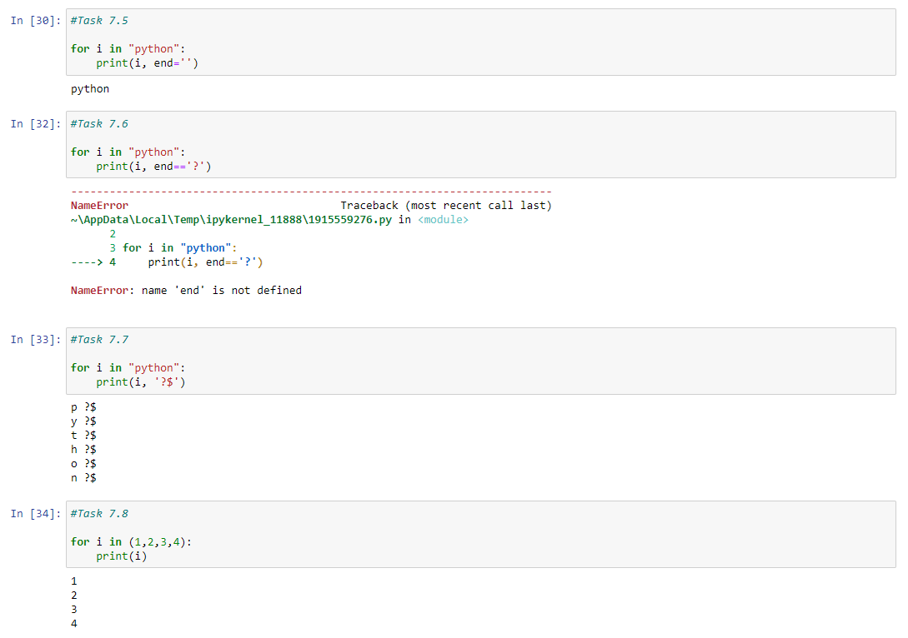

Program 8: Write a Python program to find factorial of a number
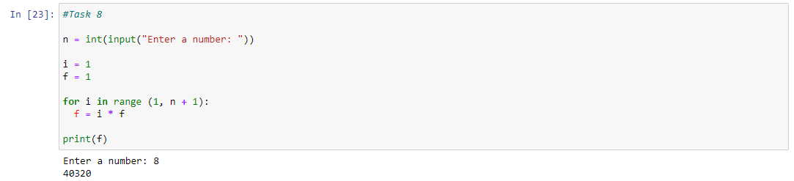

Program 9: Write a python program to reverse a given number
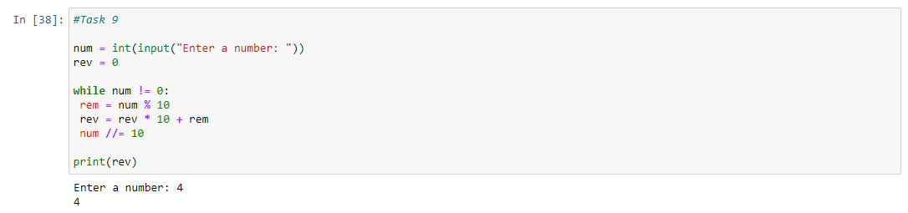
Program 10: Write a python program to generate Fibonacci number series.
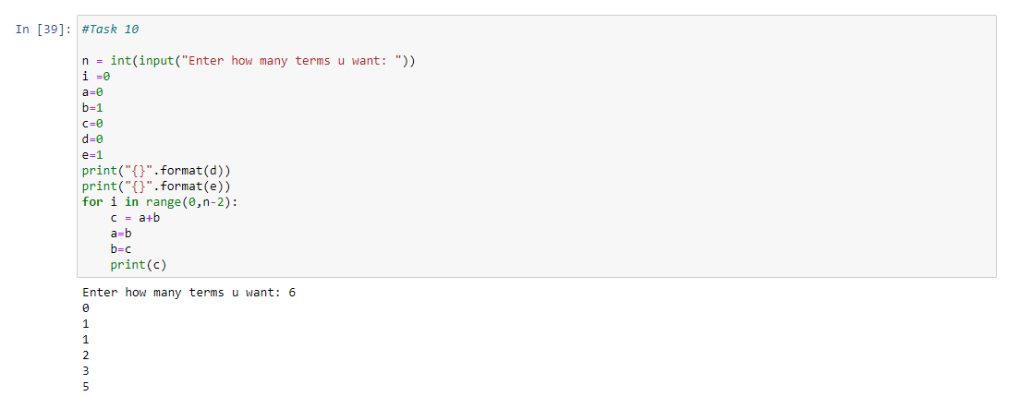
Program 11: Write a program to print all the strong numbers between 1 to 100
Note: Strong number is a special number whose sum of the factorial of digits is equal to the original number. For Example: 145 is a strong number. Since, 1! + 4! + 5!
Program 12: Write a Python program to print the following pattern:
5 4 3 2 1
4 3 2 1
3 2 1
2 1
1

Program 13: Accept the marks for the number of subjects studying in this semester. While accepting marks check the constraints that entered marks should not be negative as well as should not be more than 100 (if entered terminate the code). If the constraint is satisfied, calculate the total & percentage. If % is greater than equal to 92 display “Merit” if % is between 75 and 91 display “Distinction” if % is between 60 and 74 “First class” if % is between 45 to 59 display “Second class” else display “Fail”

